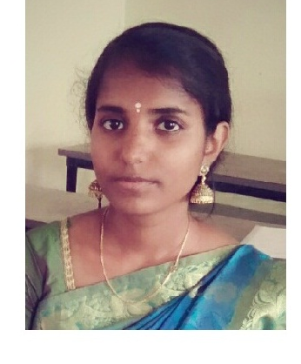**LAKSHMI PRIYA.P**

**No: 94, Pudiyana theru**

**Mela kottucherry,**

**Vadamattam,**

**Kottucherry(post),**

**Karaikal.**

**Mobile: +91 9944319762**

**E-Mail:** [**sethuvk88@gmali.com**](mailto:sethuvk88@gmali.com)

**Career objectives**

To be employed in a concern that entrust challenging work, where i can explore my skills and

talent, acquire new skills to contribute for the successful growth of the organization to the best of my

potential.

**Education qualification**

|  |  |  |  |
| --- | --- | --- | --- |
| **Percentage year of passing** | **Qualification** | **University/board** | **percentage** |
| **2015-2018** | **B.sc** | **AVVAIYAR GOVT.COLLAGE FORWEMAN,**  **KARIKAL** | **61%** |
| **2015-2013** | **HSC** | **ANNAI THETASA GOVT. (G) HR SEC SCHOOL,**  **KARIKAL**  **(state board)** | **54.3%** |
| **2013-2012** | **S.S.L.C** | **SERVITE GOVT.AIDED HS ,**  **KOTTUCHERRY**  **(state board)** | **86.6%** |

**Technical skills**

**1. I know and efficient work in java, c++, java script language, html**

**2.** Know and efficient in different software like M.S Office 2007, 2010, Windows 8.

Also well west in working with Ubuntu Linux Software. (Installation, working with data bases).

**Positive traits**

* **Responsible**
* **Hard working**
* **Good Team Worker**
* **Optimistic**
* **Good in leading**
* **Have a wish to learn and grow**
* **Disciplined**

**Personal details**

* **Father’s Name : U.PAKIRISAMY**
* **Date of Birth : 30.07.1997**
* **Sex : female**
* **Nationality : Indian**
* **Marriageable Status : Single**
* **Languages Known : Tamil,English,(Read/Write)**
* **Hobbies : listening music, play.**
* **Permanent Address : No: 94, Pudiyana theru**

**Mela kottucherry,**

**Vadamattam,kottucherry(post),**

**Karaikal.**

**Declaration:**

**I hereby declare that the above said information is true to the best of my knowledge and belief.**

**Place: KARAIKAL Yours Truly**

**Date:**

**(Lakshmi priya.p)**

**s**